Hash Set

Properties

1. Values insertion does not maintain the insertion order. That’s main difference between Set and Array List

As we look into the following example, set did not maintain the preserve order

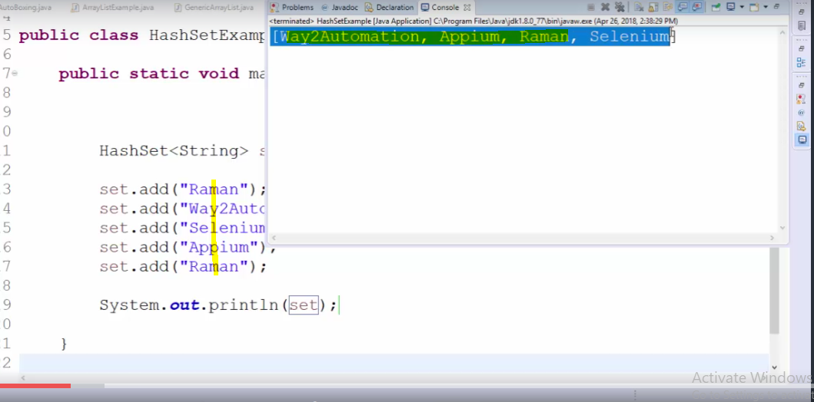

1. Set allows only unique value not the duplicate values.

Important note: Since, set does not maintain any preservation order so we cannot use ‘get’ method (‘get’ method fetched values on the basis of index only that’s why ‘get’ method is used in Array List since array list maintains preserve order).

Since we can’t use index to fetch set values, so we can not use simple for loop to fetch its values.

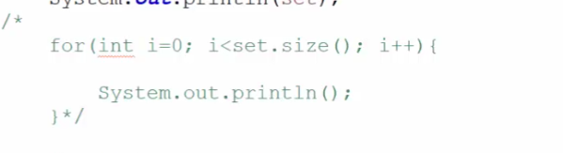

So in order to fetch its values, ‘for each’ and ‘iterator’ need to be used as follow:

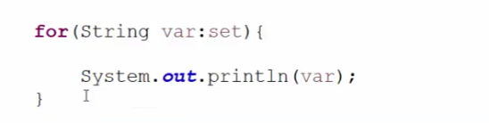

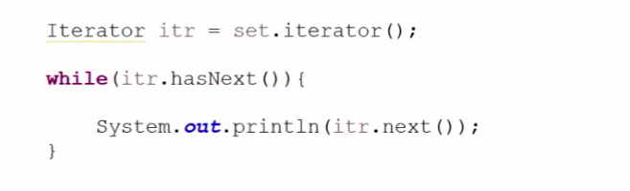

How to fetch individual value

